Researchers at Northwestern University and the University of California San Francisco are testing a positive emotion skill-building program with family caregivers of people with Alzheimer's Disease.

Six weekly skill-building sessions are delivered via videoconferencing OR via a self-guided online program, so you may participate from a location of your choice.

For more information or to see if you are eligible to participate, please call or email us.

**The LEAF Study**

**visit: leafstudy@ucsf.edu**

**(415) 514-2935 or (312) 503-5195**

**LEAFstudy@northwestern.edu**

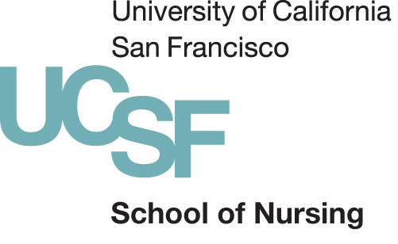



Caregiving   
can be stressful.



